**Name:** Anshul Shirbhate

**Roll No:** D – 5

**Subject:** Computer Network

**Practical No:** 2

**Title:** Use Network Utility Command like ping, ipconfig, netstat, tracert to observe the network details.

**Theory:**

**1) Ping:** Ping is a command used in CLI, Shell etc. for checking if the host/computer is up or not in a network. It is a simple way to verify that a computer can communicate with another computer or network device.

The ping command operates by sending Internet Control Message Protocol (ICMP) Echo Request messages to the destination computer and waiting for a response. The two major pieces of information that the ping command provides are how many of those responses are returned and how long it takes for them to return.

For example, you might find no responses when pinging a network printer, only to find out that the printer is offline and its cable needs replaced. Or maybe you need to ping a [router](https://www.lifewire.com/what-is-a-router-2618162) to verify that your computer can connect to it to eliminate it as a possible cause for a networking issue.

**2) Ipconfig:** The ipconfig command is used to display information about your network configuration and refresh DHCP and DNS Settings. By default, the ipconfig command displays your IP Address, Subnet Mask, and default gateway. But with correct parameters, you can get a lot more information out of it.

**3) Netstat:** The netstat [command](https://www.lifewire.com/what-is-a-command-2625828), meaning network statistics, is a [Command Prompt command](https://www.lifewire.com/list-of-command-prompt-commands-4092302) used to display very detailed information about how your computer is communicating with other computers or network devices.

Specifically, it can show details about individual network connections, overall and [protocol](https://www.lifewire.com/definition-of-protocol-network-817949)-specific networking statistics, and much more, all of which could help troubleshoot certain kinds of networking issues.

**4) Tracert:** The tracert command is a Command Prompt command that's used to show several details about the path that a packet takes from the computer or device you're on to whatever destination you specify.

You might also sometimes see the tracert command referred to as the trace route commandortraceroute command*.*

**Practical Outputs:**

**1) Ping:**

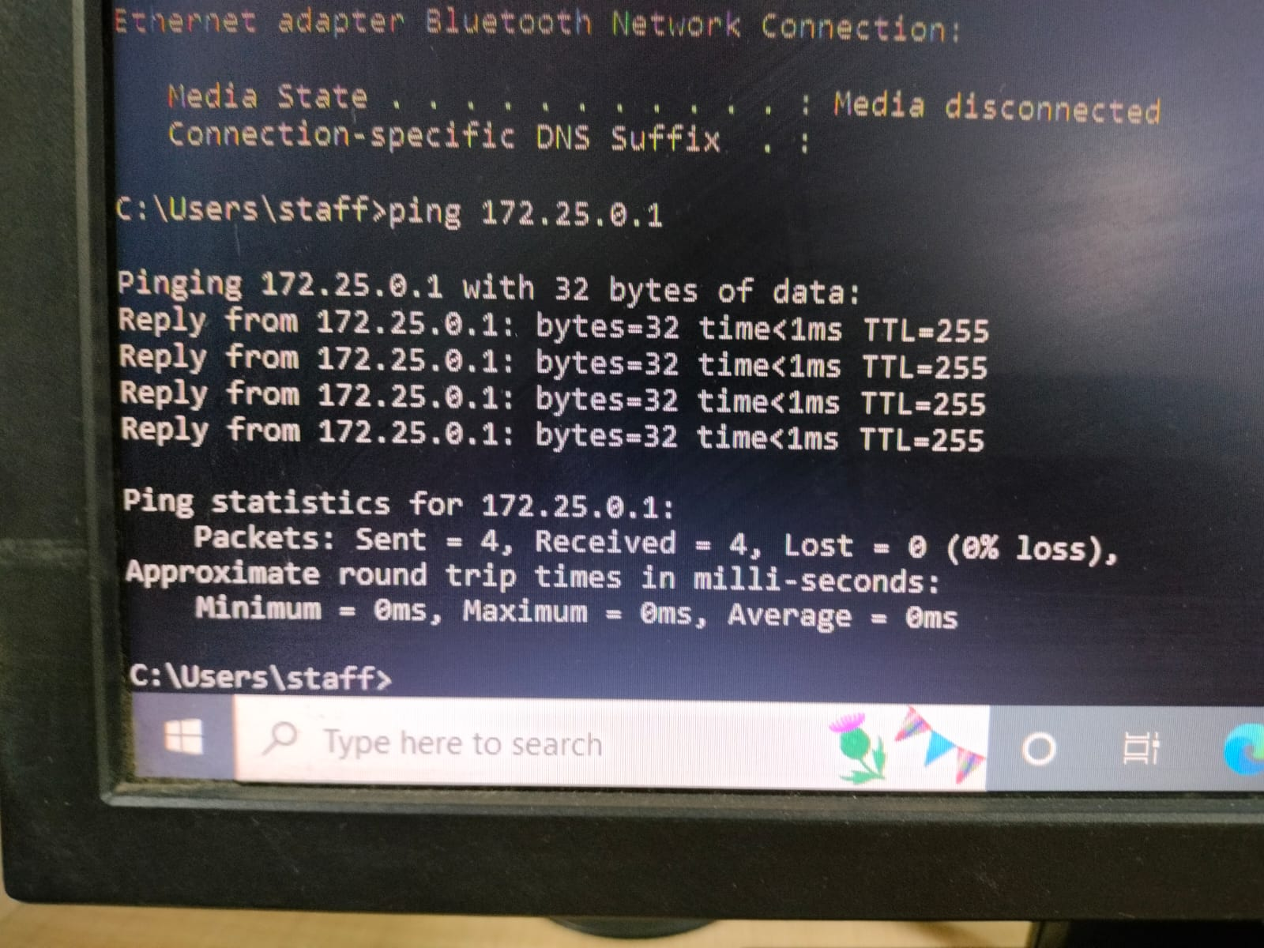

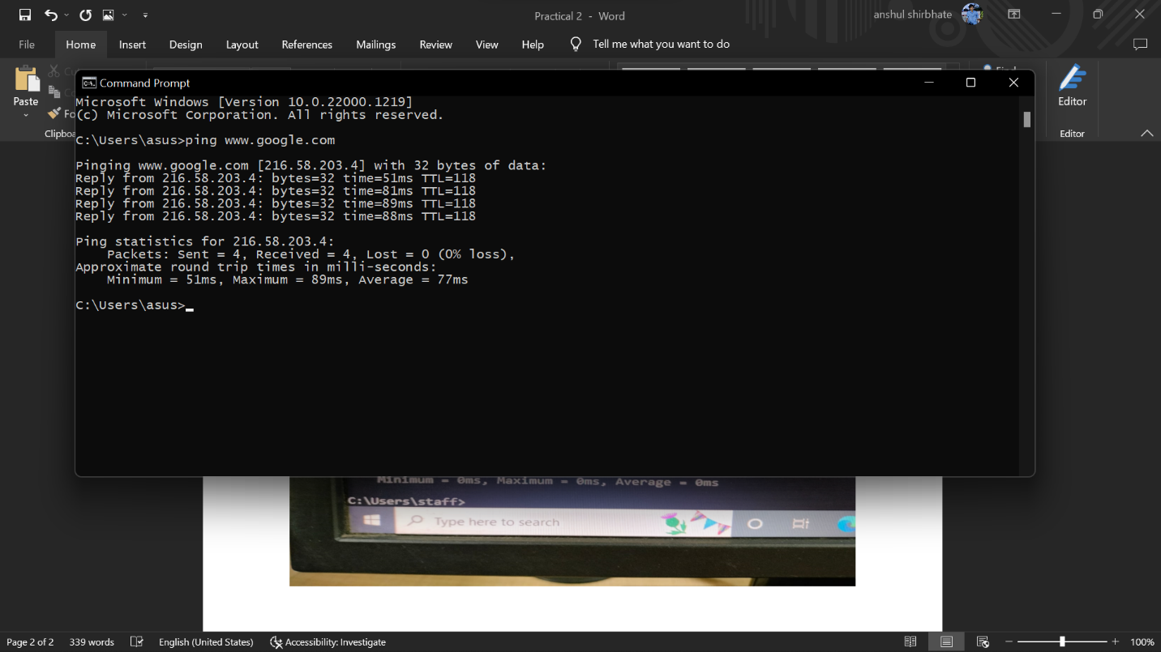

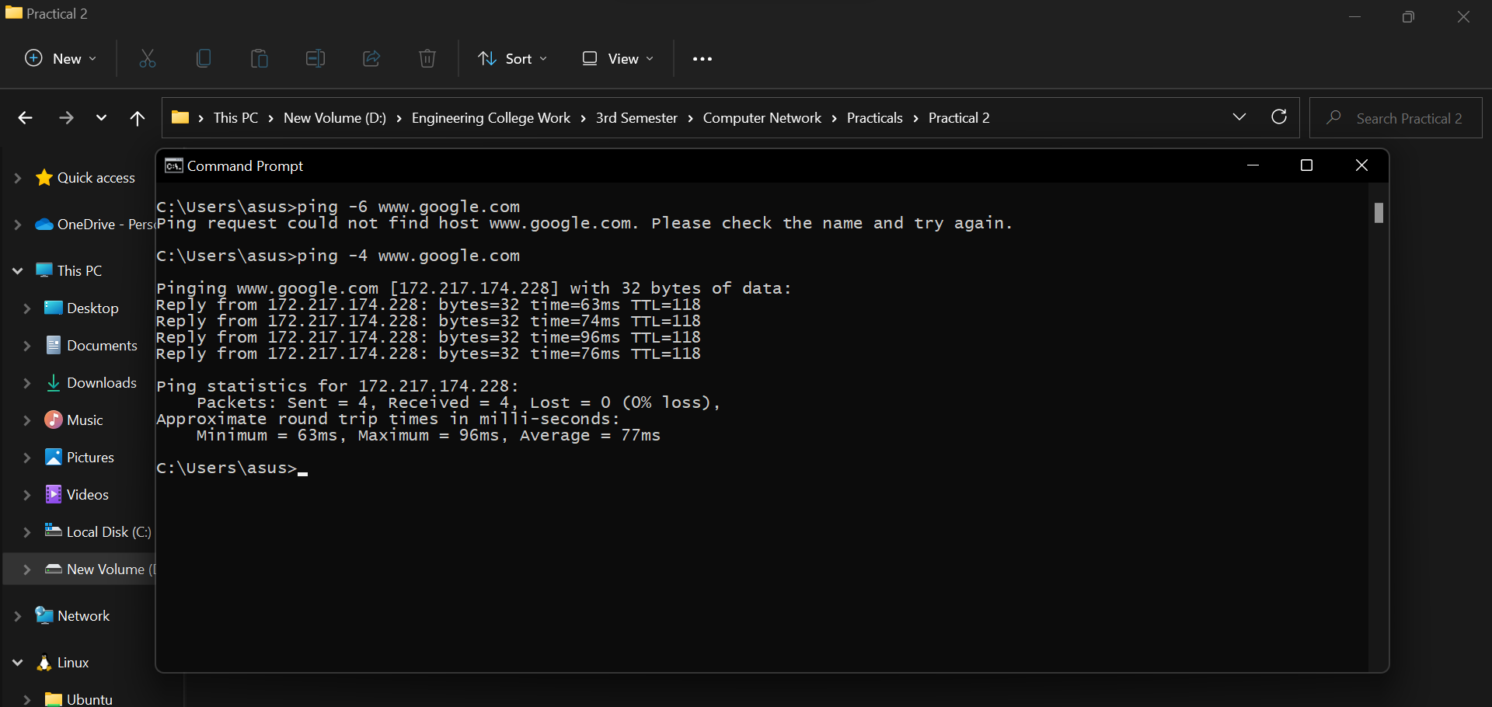

**2) Ipconfig:**

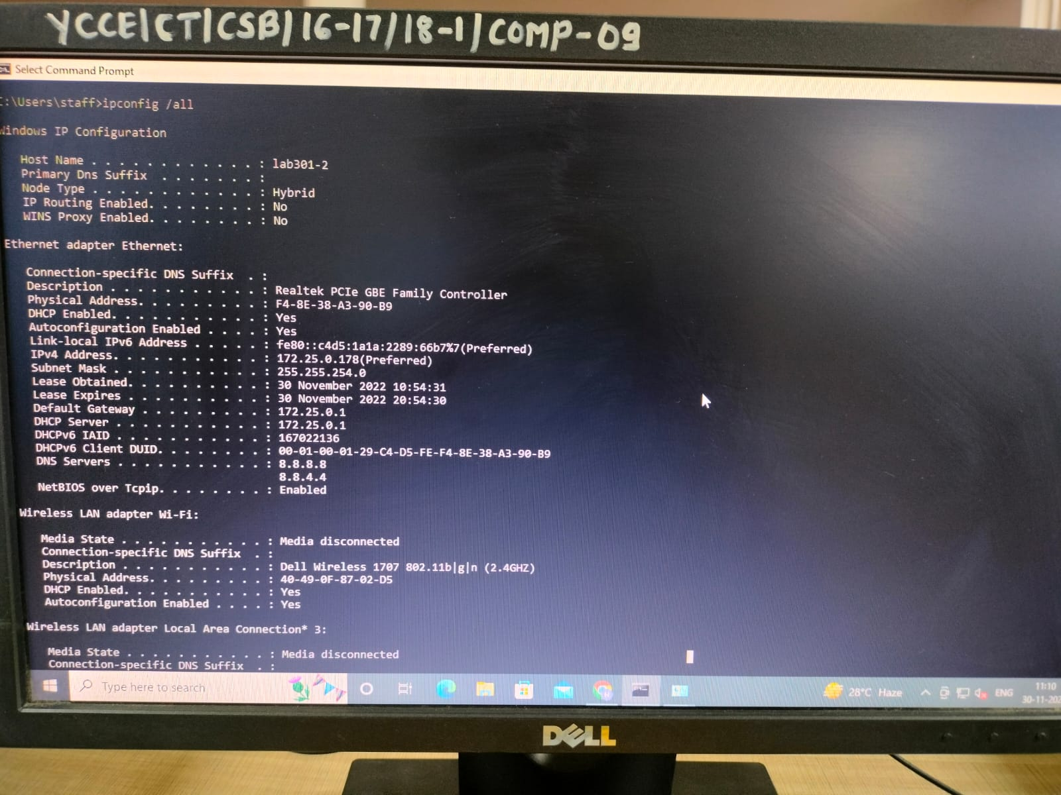

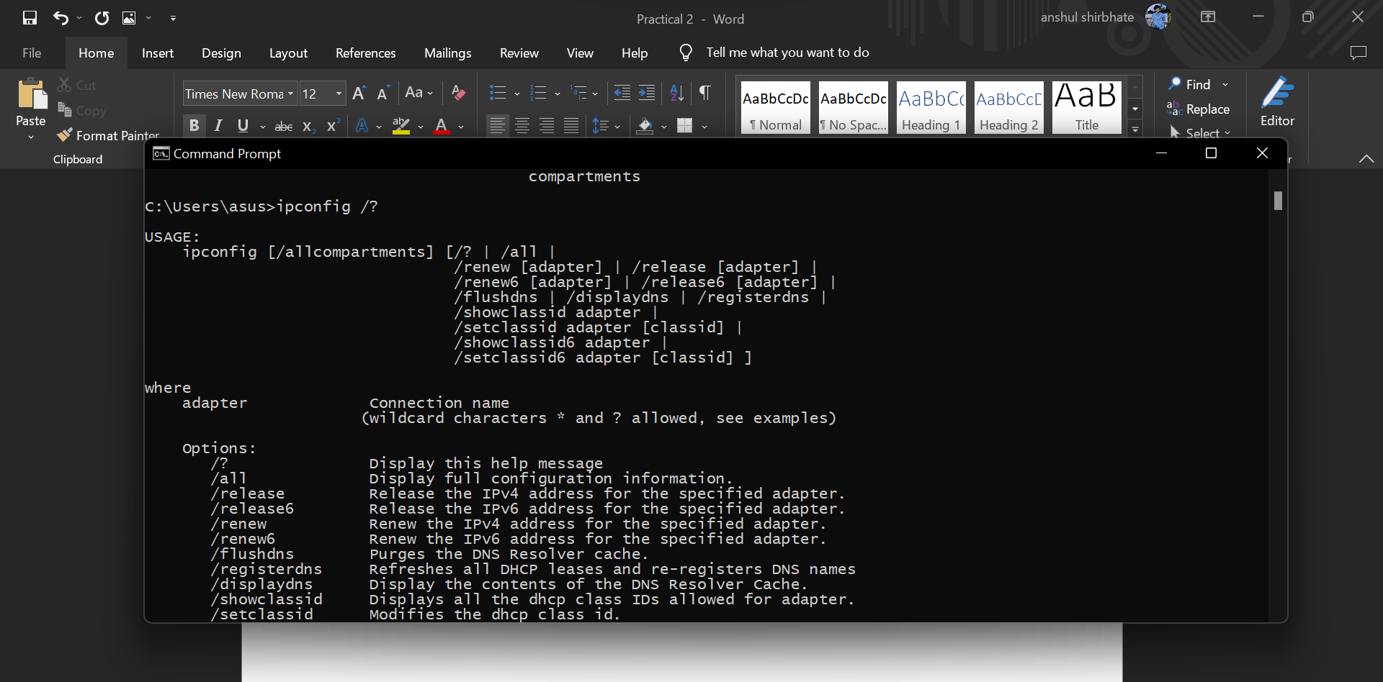

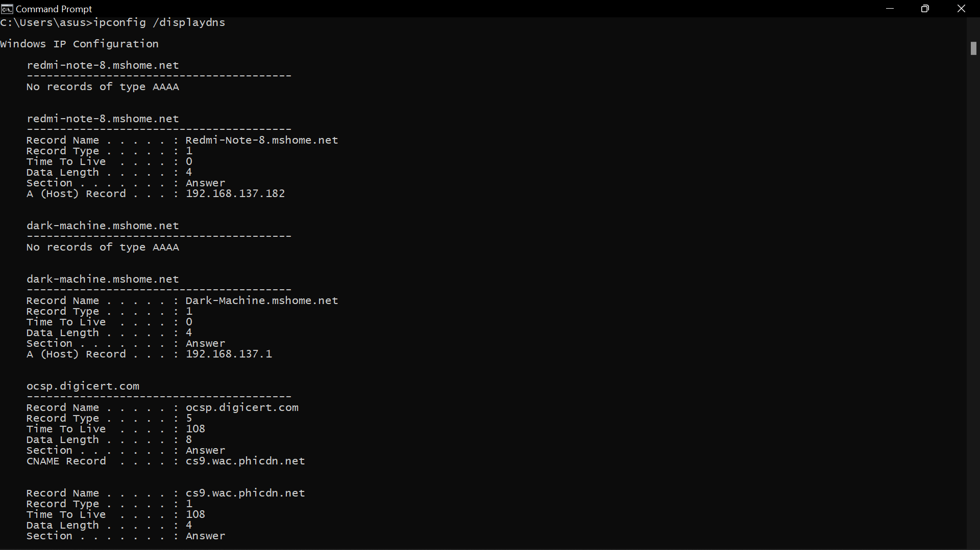

**3) Netstat:**

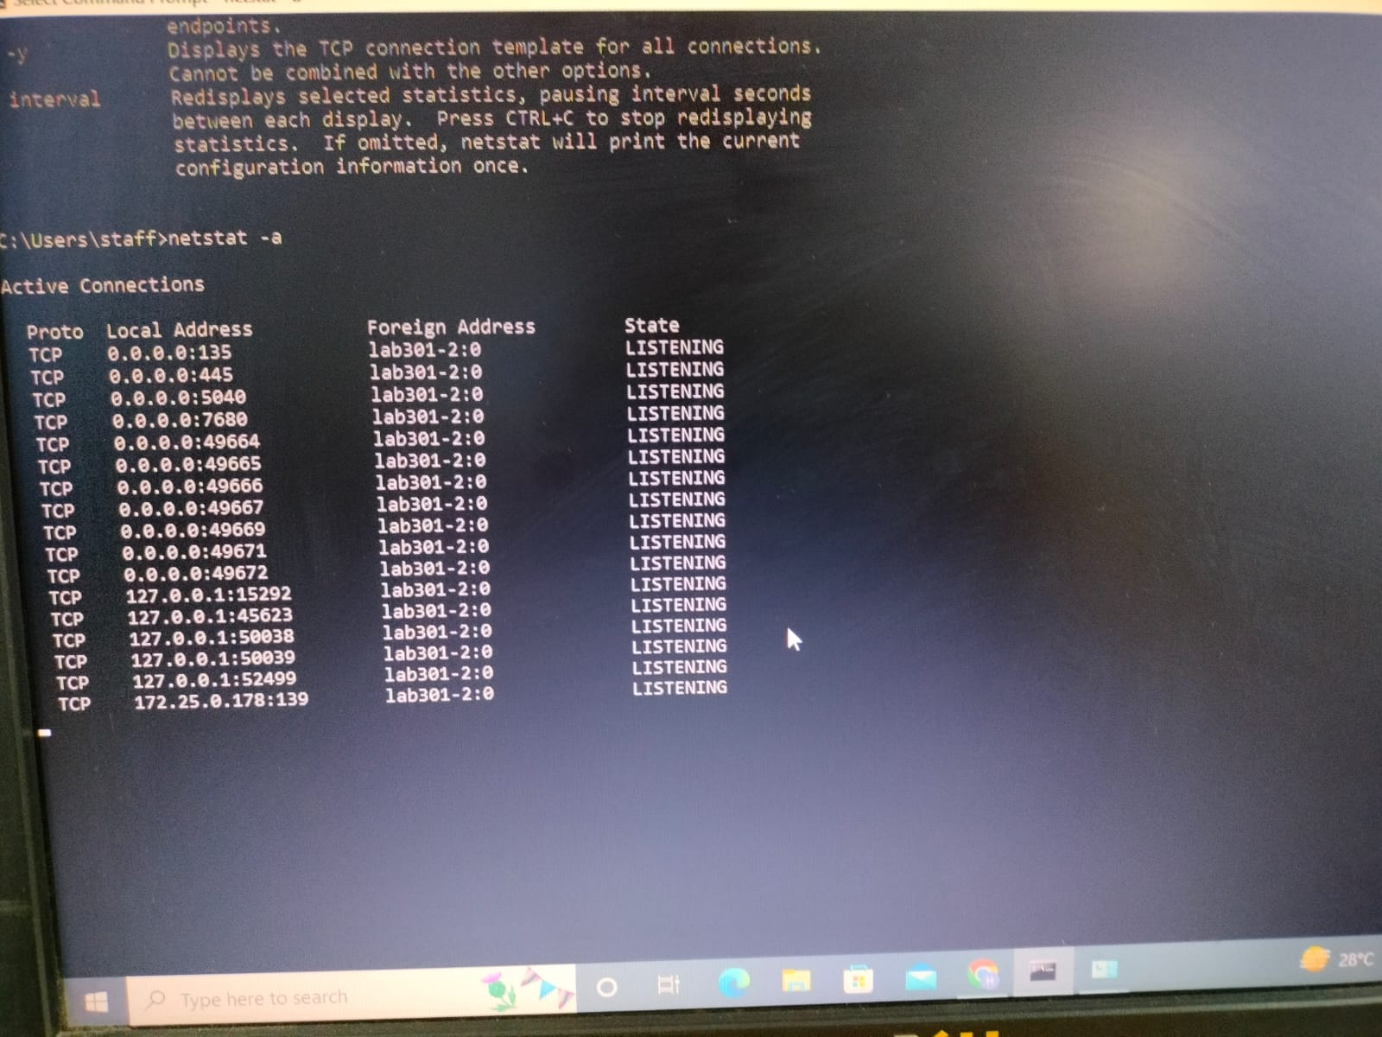

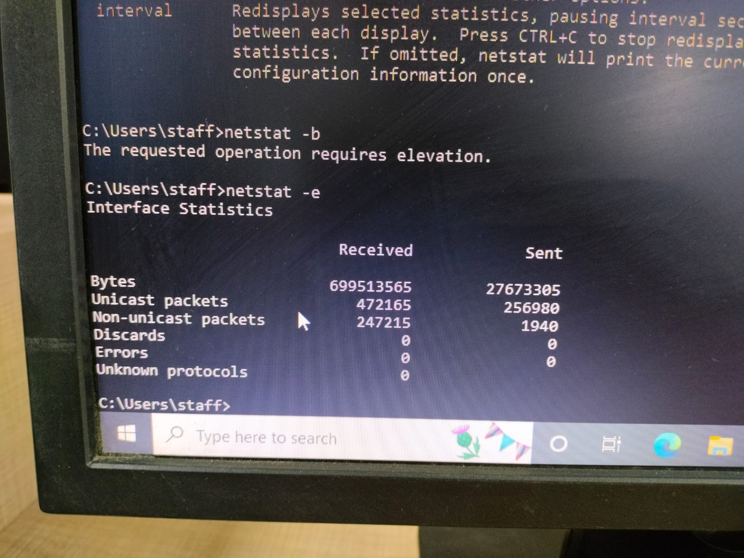

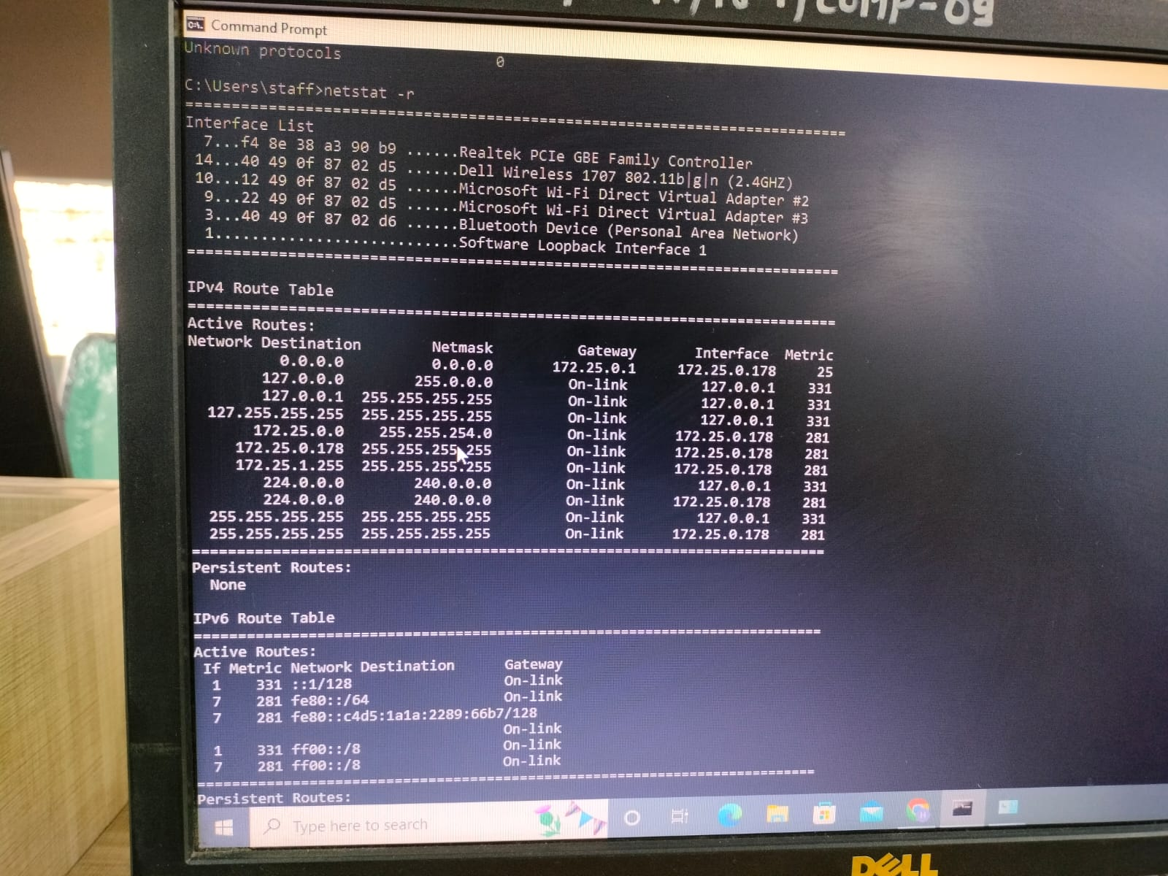

**4) Tracert:**

